Need to document parameters and runs from this point onwards.
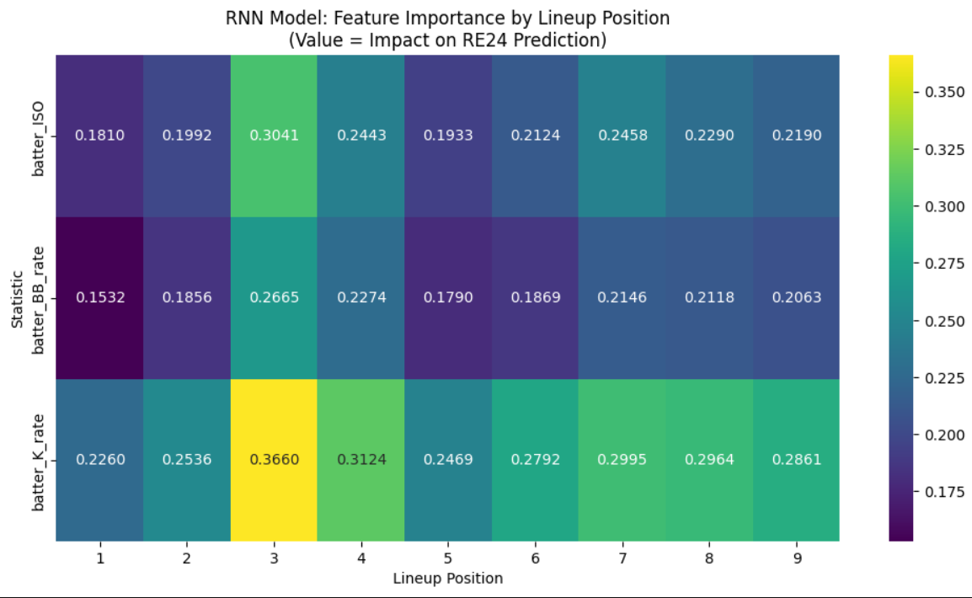
This is run 1 with a dropout of .35
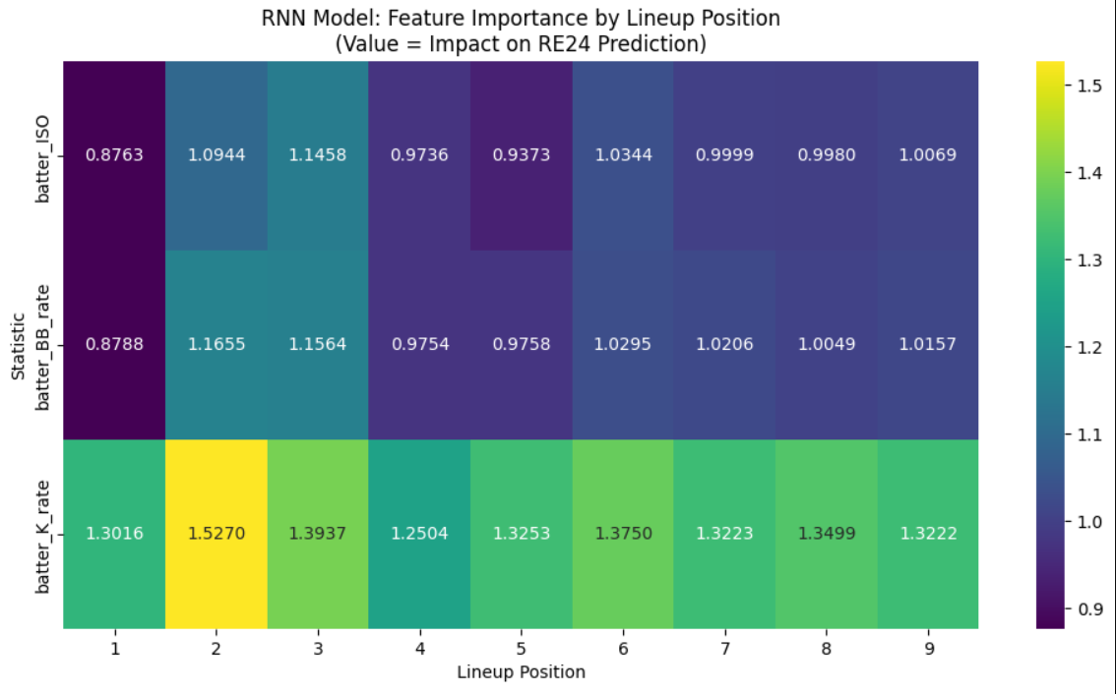
This is run 2 with a dropout of .35

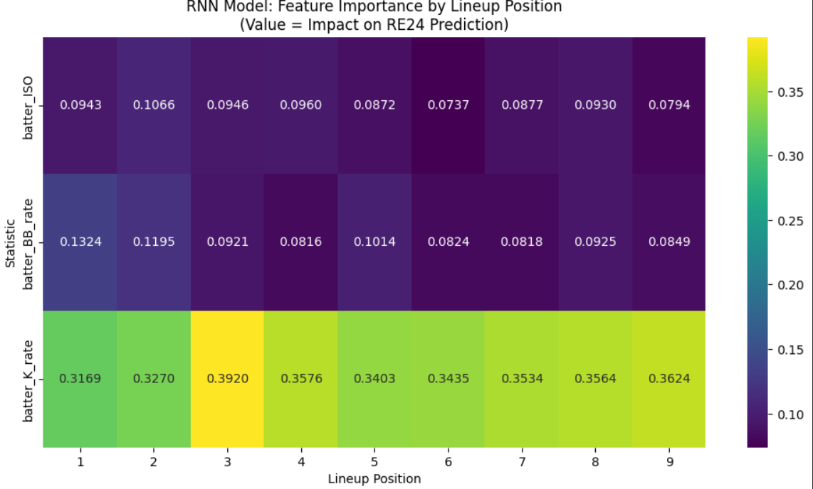
Run 3 with dropout of .20

Need to try with very little dropout
Almost 45% dropout
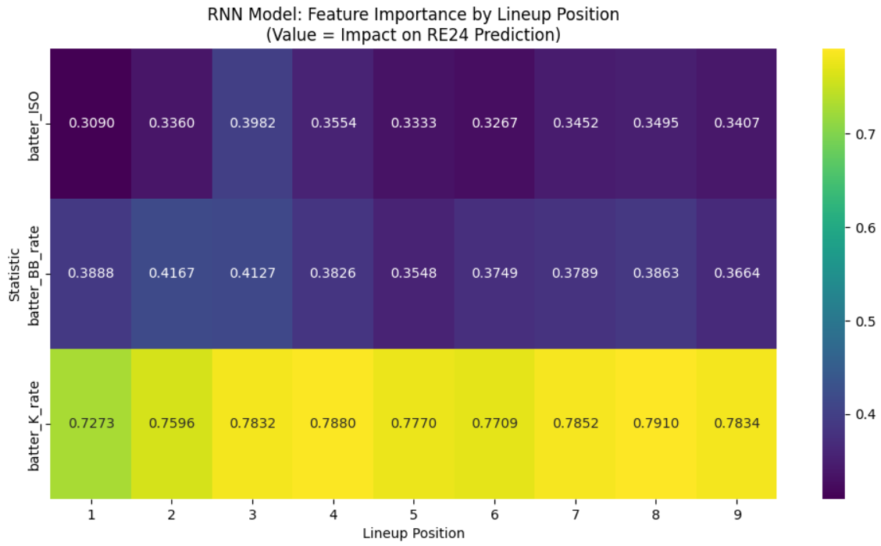
Dogshit result

